Precision Piezo – Piezo Z-Probe Kit

Thank you for purchasing the Piezo Z-Probe Kit. This device can detect the contact of your 3D printer’s nozzle with the print bed to a precision better than 10 microns, using as little as 15g of force.

Contents of package

* Piezo Sensor PCB
* Piezo disc/s (drilled or undrilled)
* 3 Wire "Endstop" Cable
* 3 and 4 pin connector housings for the endstop cable to suit your printer controller.
* 2 pin dupont-style plug/s for piezos and crimp connectors.

## Specifications

* Operating Voltage 3.3-5vdc, approx. 180mA (**NOT** tolerant of higher than 5v input)
* Indicator: Blue LED = Triggered
* Output: Active high 5v/3.3v when triggered (see appendix 1)
* Repeatability std deviation: 0.007mm
* Optimal Probing Speed: 4-7mm/s
* Probing Force: 10-15g
* Operating temperature 10-35 deg C unless retuned (see below).

## Safety

Piezo discs ceramic (PZT) contains lead. It is contained if they are undrilled and presents no hazard. If drilled trace amounts might be shed from the drilled edge so wash your hands after handling them.

If you are drilling your own please do so in a workshop area, with adequate ventilation, wipe the dust away afterwards. Do not inhale or ingest the dust. Use gloves or wash hands thoroughly.

Attach the electrical connections carefully and as directed getting the polarity of the power (red), ground (black) and signal wires correct. We are not responsible for damage to 3D printer controllers caused by incorrect wiring. The controller comes with its endstop wire pre-connected correctly.

Like many endstop devices the kit will not fail-safe (see appendix 1) although in a later version we hope to address this. What this means is that like any sensor without inherent failsafe i.e. inductive, IR, it is sensible to test the sensor before each printing session by just pushing up gently on your **cold** nozzle and observing to see the triggered LED light up to ensure it is working normally. Failure to do so in rare cases may occasionally result in a head crash.

## Instructions Mechanical

You may wish to download one of our designs for a piezo module or one of the other designs on Thingiverse <https://goo.gl/dGTBM3> and build it using our kit. Or design your own piezo probe as below:

1. The aim is to position the piezo disc or discs in such a way that they either flex across the disc or are compressed through the thickness of the disc. Doing so generates a voltage rise, which the PCB detects, if it exceeds an adjustable threshold, a trigger is generated at 3.3v or 5v (depending on Vin power) for your controller board to detect.
2. Ideally keep the leads to the piezo's from the piezo PCB as short as possible, for hotend systems place the PCB on the carriage or effector, for underbed systems place the PCB somewhere under the bed centrally to ensure short wires. Avoid running wires from piezo discs to the controller in bundles of cables containing motor wiring, and heater/fan wiring as electrical interference can reduce the effectiveness of your sensor system.
3. Your design for a sensor system is yours to consider, however the following guidance will enable you to optimise your design to get the most out of the system. A huge amount of additional information is available on the support pages of our website, <https://www.precisionpiezo.co.uk/resources-osh> please see the reprap thread, and the other designs on thingiverse for inspiration and ideas.
   1. Using drilled Piezo discs.
      1. Place the disc in the filament path above the hotend, they are drilled to enable the filament to pass through the disc either within a PTFE guide tube (1.75mm) or without one (3mm). Upwards force generated by nozzle contact needs to squeeze, or bend the disc in order to generate a signal.
      2. The bending method generates a larger signal. To create the bending effect try to support the disc on one face around its perimeter, then on the other face design a much narrower flange to press up into the disc to create the bending. Only around 0.1-0.2mm of flex is required to give a strong signal.
      3. Try to avoid direct contact with the metal of the hotend, this is to prevent a potential short circuit being created between the hotend, in the event of failure of the heater cartridge (or thermistor) and the piezo disc, which would potentially damage your controller board. If the hotend is to contact the disc consider putting a fibre washer or printed spacer between the hotend and the piezo disc.
      4. Heat will affect the piezo disc's ability to generate a signal, generally with hotend mounted piezo sensors the disc is above the hotend (above the cold-end in reality) which is actively cooled so its temperature should be only a little above room temperature in use. If using it in a chamber please tune the disc with the chamber at the typical temperature set during probing (typically before a print begins), higher than 60 deg C might be unreliable).
   2. For underbed piezo sensors
      1. In this case at least 3 piezo discs are required to cover a delta printbed or square printbed supported on 3 mounts though you can use 4. The aim is to place the piezo discs under the bed in such a way that downwards pressure on the bed squeezes or bends the disc.
      2. Various method have been tried including flexible bed supports to which discs can be bonded, so that they bend as the pressure is applied, and more complex levers which press onto the disc when the bed is pushed by the nozzle. There are 3 connectors on the PCB these are connected in parallel. If your PCB has only one piezo connector connect the discs in parallel. Ensure all three discs have the same polarity – see electrical below.
      3. Heat is problematic for piezo disc and this is especially worthy of consideration when a heated print bed is being used. Try to design your mount to keep the disc away from the heat of the bed. Tune and probe ,with the bed heated to normal printing temperatures.

## Instructions Electrical

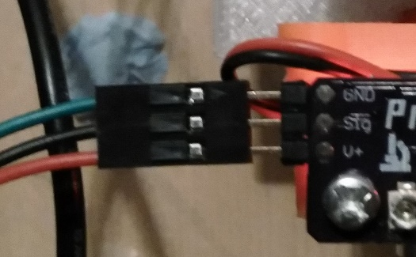

1. The kit comes with a PCB, it has an endstop connector attached The cable comes ready connected to the PCB by the three way plug at one end. If you detach it please ensure you replace it correctly, reverse polarity might damage the PCB and/or your 3D printer controller.
2. The other end has crimped connections. A 3 way and 4 way plug are provided. Please insert the crimped connectors into the plug housing in the correct order for your controller board. You should check your controller's documentation to ensure they are the right way around.

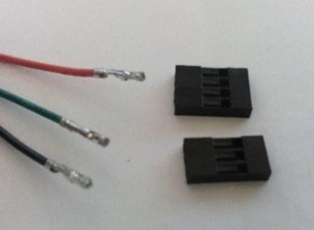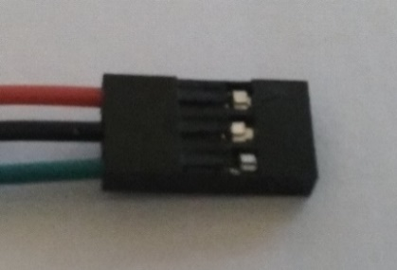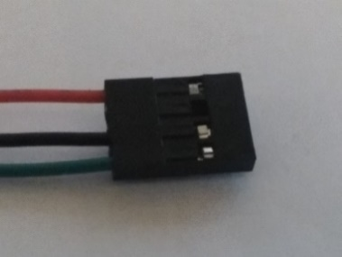The 3 pin plug shown here (middle) is suitable for ramps, the four pin (right) is setup for Duetwifi. Make sure the crimp locks into place in the plug housing, if not rotate it and re-insert it. Check your controller board's documentation carefully!

1. The piezo disc should be attached to a two pin dupont-style 2.54mm/0.1inch connector. It has a red lead and a black lead. We do not pre-crimp these for you as you may need to extend the leads from the piezo to suit your design. You cannot always presume these are positive-red and negative-black as it depends on the ceramic contained within. However there is a method by which you can test it.
   1. If you have an oscilloscope attach it to the disc with Red to your probe connector, and black to ground. Press or bend the disc in the same way you intend to use it in your implementation, and ensure the trace shows voltage rising as it is pressed. If voltage rises as you release it the polarity may need to be reversed when connecting it to the PCB. There another method which can be used after assembly see "tuning" below.
2. If you have multiple discs then they should be connected to the PCB either individually or if your PCB has only one piezo connector so that all their positives and negatives are joined in parallel. As in 3 (above) polarity might need to be checked and reversed, see tuning below.

## Instructions Firmware

In your firmware you need to configure a z_min_endstop or z_probe. Follow your manufacturer’s instructions and those for your firmware. More details can be found on thingiverse <http://www.thingiverse.com/thing:2069480> however firmware changes so use the forums to keep up to date. The PCB provides a 5v or 3.3v (depending on input voltage) signal which rises on trigger (active high/Normally Open).

## Tuning

Please ensure your piezo disc/s are installed in your setup, that the PCB is powered up, and that the piezo disc is connected to the PCB.

* For hotend probes set your hotend to around 130 Deg C (see “operation” below for why).
* For underbed probes set your print bed to normal printing temperature for your chosen material.
* If using in a chamber heat your chamber to normal temperature you would use during probing I.e. at the start of a print typically. Approaching 60 Deg C some piezos will lose the ability to produce a clear signal, so probing with a lower chamber temperature is advised.

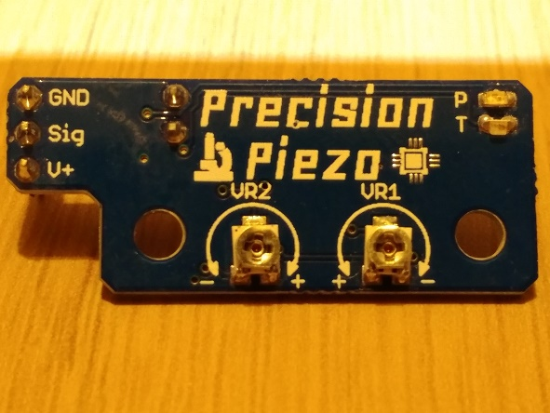There are two PCB designs we supply they are both the same circuit and do the same job. One is common with our ready built sensor modules the other is generic. The adjusters perform the same functions but are in different places on each board.

There are two adjustments possible. There is a LEFT/VR2 adjuster and a RIGHT/VR1 adjuster. The 1.2 PCB which has the 3 piezo inputs has these marked on the board, the precision piezo PCB they are LEFT and RIGHT as shown in the image.

It helps sometimes to read the value of the RIGHT/VR1 adjuster with a multimeter set to measure resistance/ohms. Measure from the piezo negative (-) connector, to the **centre** of the RIGHT/VR1 adjuster. The best starting value is 0.4Mohm. Set this value. If you are not sure if you can do this without risking shorting something with your multimeter probe remove the endstop (GND, Sig, V+ connector) before measuring.

1. 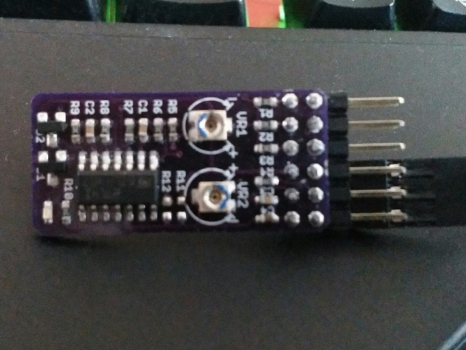Using a small insulated screwdriver, carefully turn LEFT/VR2 adjuster- at a certain point the blue triggered LED goes out. Set it to the point *just* below the point where the LED goes out.
2. RIGHT/VR1 adjuster is a sensitivity adjustment. Tap lightly upwards on your nozzle (use a tool if hot), you should see the triggered LED light up positively. Move the head around and see if it triggers from normal head movement, if so turn the RIGHT/VR1 adjuster down to reduce sensitivity. The two adjustments affect one another so move to step 3. It helps to measure the resistance of VR1 with a multimeter. Measure from the middle of the adjuster (or via your screwdriver) to the/any piezo negative (-) pin. If you read from the piezo positive (+) pin you will always read approx. 10kOhm, so use the negative pin. A value of 0.4mOhm is the recommended starting point, higher resistance/value means more sensitive.
3. After changing VR1 (higher resistance is more sensitive, lower resistance is less sensitive) you should repeat step 1. Slight flickering during moves is acceptable as this is below trigger level. It is a balance between too sensitive resulting in too many false triggers, and not sensitive enough which might not trigger on probing. Once set move on to section "operation" and test that it triggers normally. Optionally mark the adjusters. See "mechanical noise" below
4. POLARITY CHECK – after tuning is complete press up on your COLD nozzle sharply and observe the triggered (blue) LED. If it flickers on briefly *as you press up* then the polarity is correct. If it flickers on *as you release the pressure* then it is reversed. Reverse the piezo plug and go back to step 1 above. For underbed piezo's press down sharply on the bed, observe the triggered LED flicker on as you press down. Press down on the bed over each of the three piezos and check the same behaviour, also press in the middle of the bed and ensure the same behaviour. If any individual piezo generates the triggered LED when you release the pressure its polarity is wrong, reverse it at the PCB. Not all piezos have the red and black wires the right way around, though we do try to test them before we ship them.
   * Please note If your design is such that the piezo is bent in the other direction from most common designs the polarity might need to be the reversed. I.e. a design using levers which pull on the disc when the bed is pressed downwards.
   * When you first test the probing if it performs badly and seems to trigger late check the polarity.
   * Electrical interference – if when tuned you notice a lot of flickering on the triggered LED, especially when you aren't moving the hotend or bed, then it might be electrical interference, this is reduced by keeping piezo leads short and avoiding routing them with motor/fan/heater wires.
   * Mechanical noise is the vibrations caused by movement of the printer (bearings, motors etc..), piezos are very sensitive and will detect it. If the sensor is attached to an axis that must move when probing I.e. a corexy wth moving Z then low acceleration and zero jerk when probing will help a lot.

## Operation

Probing is done by contact of the nozzle with the bed surface. Probing speed should be between 4-7mm/s (240-420mm/min) it is the equivalent of a gentle tap on the bed. Very slow probing might not trigger the device which works by detecting a voltage rise as it is bent/squeezed quickly, think of it as somewhere between a microswitch and a microphone. You might need to increase your Z max feedrate if you use fine pitched leadscrews on your z axis, this works with low z-acceleration (100 mm/min).

**Piezo Sensors are very sensitive this makes them excellent z-probes however they are so sensitive false triggers can occur If your probe is on an axis that moves during the actual probing "dive" (I.e. underbed on a corexy) use zero jerk and low acceleration for probing (in your start gcode or macro). If the probe is on an axis that is stationary when the probing dive takes place you can use pause before probing (now available on all major firmwares after we requested it) coupled with Z-acceleration of 100-200 mm/min.**

When first testing if possible (and easy to do from software) reduce your stepper motor currents to a minimum so that if it does not trigger no damage will occur, this is practical if your motor currents are set from software, i.e. digipot/duet etc.. Move your nozzle away from the bed around 100mm, command a single probe (G30 in most firmware) and then lightly tap the nozzle upwards as it descends with a finger/tool **before it hits the bed**. The firmware should respond, usually by moving the nozzle upwards (or bed downwards in the case of a bed moving in Z). This indicates that the kit is working and that the firmware is properly configured. If nothing happens, kill the power to avoid a head crash, check the firmware z_min or Z-probe logic is correct, if unsure reverse it and try this test again.

When you are confident it triggers on contact you can now use the kit for 3 functions:

1. Homing to Z-min.
2. Autolevelling/grid levelling/auto calibration
3. Setting the first layer height/enabling quick bed changes.

Homing to Z_min

This is self-explanatory, when firmware is set to home to Z-min the probe will trigger when the nozzle contacts the bed. This sets the z origin or z=0 level. This is best done with the probe at the bed centre but ensure the nozzle is somewhere over the bed when homing z.

Autolevelling/grid levelling/auto calibration

Probing across the bed can compensate for irregularities, tilt and in the case of deltas with appropriate firmware can calibrate the machine.

Setting the first layer height/Quick Bed Changes

This is most useful where a machine is perhaps not mechanically perfect and the level varies from time to time. After levelling or calibration, you can send G30 Z0 in Smoothieware or G30 in RepRapFirmware to reset the Z level which should mean the nozzle is the correct distance when you begin printing (provided you set the correct z offset - see below). This command can be added to your starting gcode, so if you remove one printing surface, and insert another a variation in thickness will not require you to perform lengthy calibration/adjustment, one quick probe or home and you can print immediately. This probe is not affected by reflectivity of the surface or coatings like hairspray/3dlac on the bed.

Z offset

Whilst there is no x or y probe offset as the probe is the nozzle, and this is one of the most advantageous features of this system, there does need to be a slight Z offset as the assembly bends slightly on probing. To measure this home_z (if using probe as z_homing device) or send G30 to probe once. Then raise the nozzle and insert a piece of paper, lowering it manually in small increments (0.05-0.1mm) until it is gripped firmly. Measure the difference between the z=0 after the G30 and the Z level with the firmly gripped paper between nozzle and bed. This is likely to be 0.1-0.2mm now enter that in your firmware as z_probe offset, use a negative value i.e. enter it as -0.1. You can add this in your slicer instead using Z-offset +0.1 for example. Use something thinner than paper for an even more accurate result. Some firmware such as RRF allows G30 S-1 which reads out the distance travelled from which you subtract from the height before you sent the command, this means no paper is needed.

Temperature of Nozzle and Bed, Cleaning the nozzle

You should probe with a **clean nozzle**. Clip any residual filament from it with a wire cutter or similar instrument. It is possible to probe with slight residue on the nozzle if probing hot (see below) but large amounts of filament might affect the accuracy of your result (and leave blobs of filament on your printbed).

For best practice, we advise to set the nozzle to 130 deg C or thereabouts, which should be below the “ooze-temperature” of almost all filaments but allow deformation of any residue. To the best of our knowledge a momentary contact of a hot nozzle will not damage any common printing surface, filament when extruded is hot. Clip any residual filament from the nozzle. The bed should be set to the normal first layer temperature for the material you are using. This is especially important if your bed deforms when hot and you intend to use mesh/grid-levelling or equivalent to facilitate better printing.

It is possible to probe with nozzle and bed cold, if your nozzle is very clean. After probing heat up your printer’s bed and nozzle then use the method above to calculate the z-offset.

We calculate for an e3d v6 hotend the thermal expansion of the heater block and heatbreak from 130 to 250 deg C is only 0.02mm you might choose to factor that in to your z-probe offset, but it will make little difference to a typical 0.2-0.3mm thick first layer.

Additional Information

As your nozzle moves over a previous layer, the triggered LED might flicker or light up, the sensor is so sensitive you are detecting nozzle contact with the previous layer. This will not affect your printer’s operation as long as your firmware is set to "use endstops only for homing" or if you have connected the sensor to a dedicated z-probe connector. However, it is useful to see if your print is progressing well, a lot of contact with the previous layers may indicate over-extrusion or curling of overhangs or blobs on the print. More triggering on one side of the print than the other might indicate a bed level issue.

Appendix 1

With the Piezo Kit PCB (v1.2x series) it is possible to operate the triggering in Normally Closed (NC) mode instead of Normally Open (NO). What this means in essence is that in NO mode the voltage on the signal output is 0v. When triggered it jumps to 5v (or 3.3v if your system controller is 3.3v) which registers a trigger in the firmware.

The issue with NO mode is that it does not fail safe, this is why we recommend checking the piezo system is working by tapping the hotend or bed (depending on where sensors are located) before a printing session to check for normal function. Failing safe means in the event the piezo system is not operational then the controller registers a trigger and stops moving the head or bed towards one another. This avoids a head crash.

In NC mode voltage on the z-probe (or Z-min) signal pin is 5v/3.3v unless triggered when it goes to 0v, this registers a trigger. If the piezo board fails then the voltage will be 0v and therefore the printer stops moving as it registers triggered immediately after starting the move.

To set NC mode all you have to do is when tuning, turn the VR2 adjuster to the point where the LED is just ON, rather than just OFF. The firmware needs to be set to expect a NC signal (also called inverted, or falling signal on some controllers). In this mode the LED stays on, when triggered it goes OFF (the opposite of NO mode).

**PLEASE NOTE if you also use our Piezo20 ready made module with its custom PCB (has precision piezo written on it) this unit CANNOT be set to NC mode without damaging the triggered LED which is very bright to enable light up operation of the module, and when powered by 5V is slightly overpowered and therefore cannot remain lit for long periods.**